TABLE OF CONTENTS

* **Introduction**

#### Purpose

* 1. **Product Scope**

## Product Description

* **System Features**

#### User Panel

1. **Owner Panel**
2. **Admin Panel**

## Non-functional Requirements

**1. Performance Requirements**

INTODUCTION

#### Purpose

This document lists down all the requirements for The Car Rental Application, a project being developed by Hero Vired. The document is intended to serve as the sole guide during the design and development of the project.

#### Product Scope

In today market there are people who have cars, but not use plenty times and there people who don’t have car also can’t buy one because of the market price.

For them The Rental Car application provide a opportunity, those who have cars than can listed themselves as a owner, those who have not they can listed them self as a user. So the owner can earn some penny and user can get a good experience.

### PRODUCT DESCRIPTION

The Car Rental Application has three Dashboard Users, Owners and Admin. The user can look all the car listed, Book a car which he/she like for rent, show his/her booking status.

The owner can add a car , edit the car details along with he can make changes in future also perform a delete operation and he/she can his/her car status.

The admin can manage all the users, owners and cars listed in the application and he can see all the status of the cars booking.

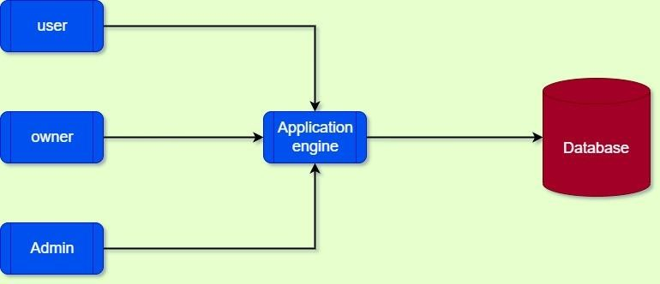``

SYSTEM FEATURES

# USER PANEL

#### Registeration Application

User can perform registration by his/her name and password.

#### Login Application

A user can login through his/her user name and password, for getting into the Home page. There is no other option will be available for login to the page.

#### Cars Viewed

User is able to see all the listed cars and there specifications on the home page. And can shortlist.

#### View Owners

User can see all the cars and who listed the cars.

#### Booking Status

User can perform a booking operation with any car he/she likes.

#### Status view

User can check the status of car booked, time-slot, transaction-amount etc.

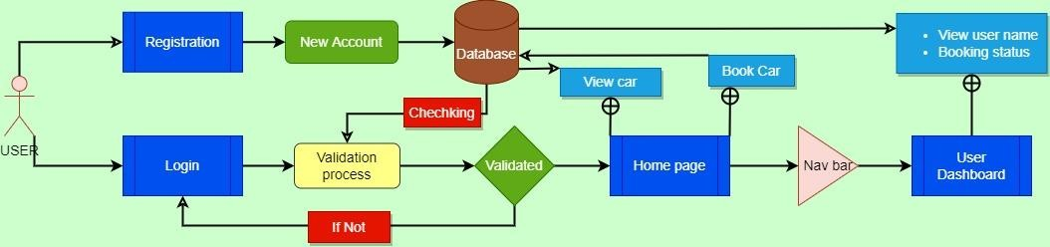

# OWNER PANEL

#### Register Application

Owner can perform registration by his/her name and password.

#### Login Application

Owner can login through his/her username and password, for getting into the Home page. There is no other option will be available for login to the page.

#### Cars additon

Owner can add cars with their specific details.

#### Car info editing

Owner can perform an edit operation if he/she want to change something about car.

#### Status

Owner can check the status of car rented by who, timeslot, transaction-amount etc.

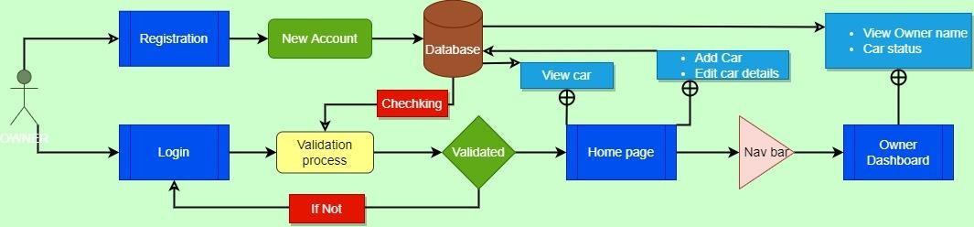

# ADMIN PANEL

#### Register Application

Admin can perform registration by His/Her name and password. No other mean of authentication required for an admin profile.

#### Login Application

An admin can login through his/her user name and password, For getting into the Home page. There is no other option will be available for login to the page.

#### Cars information

Admin is able to see all the listed cars and there specifications on the home page.

#### Users information

Admin can able to see through all the users who are listed in the application at admin dashboard. Like there name, contact details.

#### Owners information

Admin have access to all the Cars-Owners. He/She can see all the cars and who listed the cars.

#### Status

Admin can check the status of car like booked or not, time-slot, transaction-amount, who is the user and whose car it is.

#### Users management

Admin have the authority to manage Users account. He/She can delete the user account if unnecessary behaviour find in the account.

#### Owners management

Admin can manage the Owners account. He/She can delete the Owner account if unnecessary behaviour find in the account.

#### Cars Details management

Admin also have access to edit the details of cars which are listed by owners.

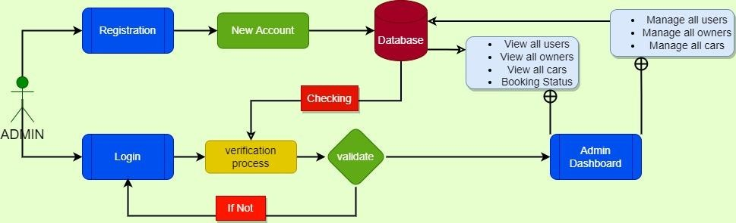

NON-FUNCTIONAL REQUIREMENTS

#### Performance Requirements

The platform is expected to support multiple simultaneous logins as well as online bookings.

It should also be able to handle moderate to heavy traffic without any issues.